Grade 7 Accelerated · Unit 6 · Thread B · Day 2  Interior and Exterior Angles of a Triangle  Question Bank - Additional 6.T2 | Name______________________  Date______________________  Period____________________

Show your work. Circle your final answer.
For questions 1 through 4, find the angle.
1. The third angle of a triangle with angles of 29° and 88°

2. The third angle of a right triangle with an angle of 44°

3. The exterior angle whose remote interior angles are 33° and 79°

4. The other remote interior angle, when an exterior angle is 125° and one remote angle is 68°

For questions 5 through 7, find x and the angles.
5. A triangle's angles are 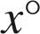, 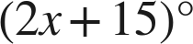 and 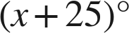.

6. An isosceles triangle's base angles are each  and the third angle is .

7. An exterior angle is 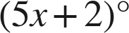; its remote interior angles are 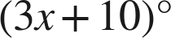 and .

Choose one.
8. A triangle's angles are 25°, 65° and 90°. What is the exterior angle beside the 65°?
○ A. 115°
○ B. 65°
○ C. 295°
○ D. 25°

9. Which equation finds x when an exterior angle is 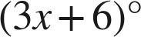 and its remote interior angles are 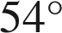 and 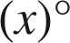?
○ A. 
○ B. 
○ C.
○ D. 